MODULE 4 – INTRODUCTION TO DBMS

LAB EXERCISES

15. SQL Group By
Lab 1.
Group books by genre and display the total number of books in each genre.
Ans.
1. SELECT genre, COUNT(*) AS total_books FROM books GROUP BY genre;
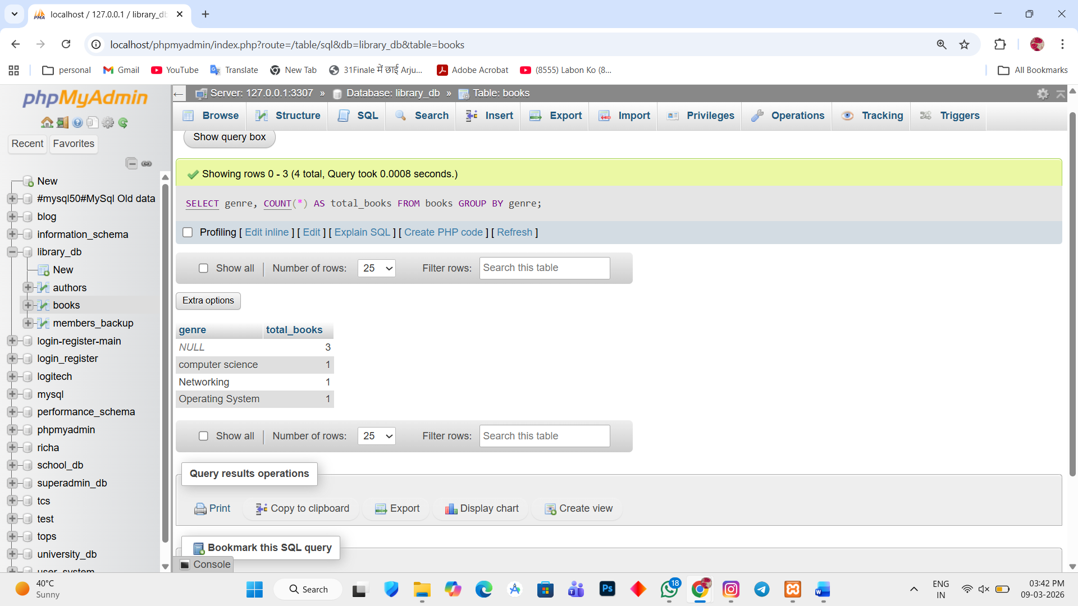

Lab 2.
Group members by the year they joined and find the number of members who joined each year.
Ans.
1. SELECT YEAR(date_of_membership) AS join_year, COUNT(*) AS total_members FROM members_backup GROUP BY YEAR(date_of_membership);
